EXPERIMENT-04
Aim: Implementing Services in Android. Develop a service that runs in the background and performs a simple task. Observer the life cycle of the service and its interaction with the main application.
Android Timer Service Example
Objective: Develop a Service that runs in the background and performs a timer task. The service will count seconds and show them using Toast.

Theory:
An Android Service is a component that runs in the background without a user interface. It is used for long-running operations such as timers, music playback, or data synchronization. Services continue running even when the user is not interacting with the app.
- Create Service Class
  - Open Android Studio
  - Right-click package → New → Service → TimerService
● Implement:
    - Use a thread to run a timer in background
○ Increment seconds every 1 second using Thread.sleep(1000)
○ Display timer using Toast
○ Override lifecycle methods:
■ onCreate() → shows "Service Created"
■ onStartCommand() → starts timer
■ onDestroy() → stops timer
- Register Service
  - Add in AndroidManifest.xml:
<service android:name=".TimerService"/>
- Design Layout
  - Create activity_main.xml with:
    - Start Service button
○ Stop Service button
- Implement MainActivity
  - Initialize buttons using findViewById()
● Add click listeners:
    - Start button → startService(Intent)
○ Stop button → stopService(Intent)
- Run Application
  - Click Run
  - Start service to begin timer
  - Stop service to end timer
Code:
TimerService.java
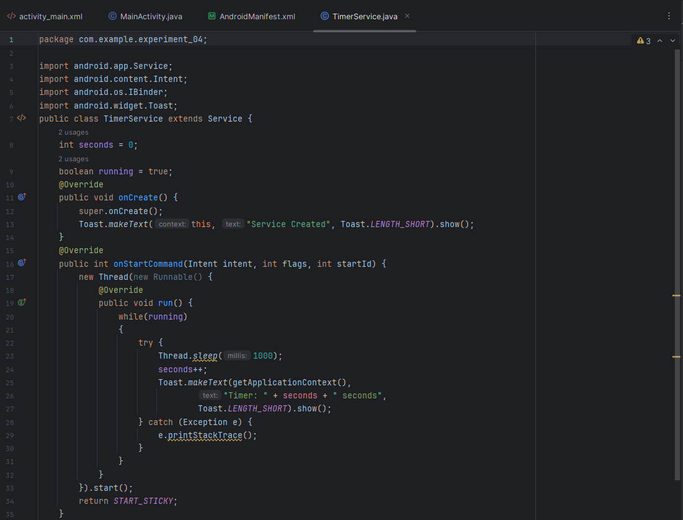
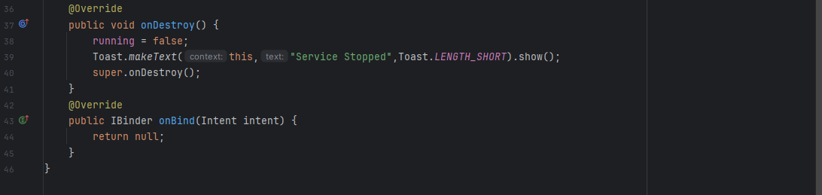

activity_main.xml
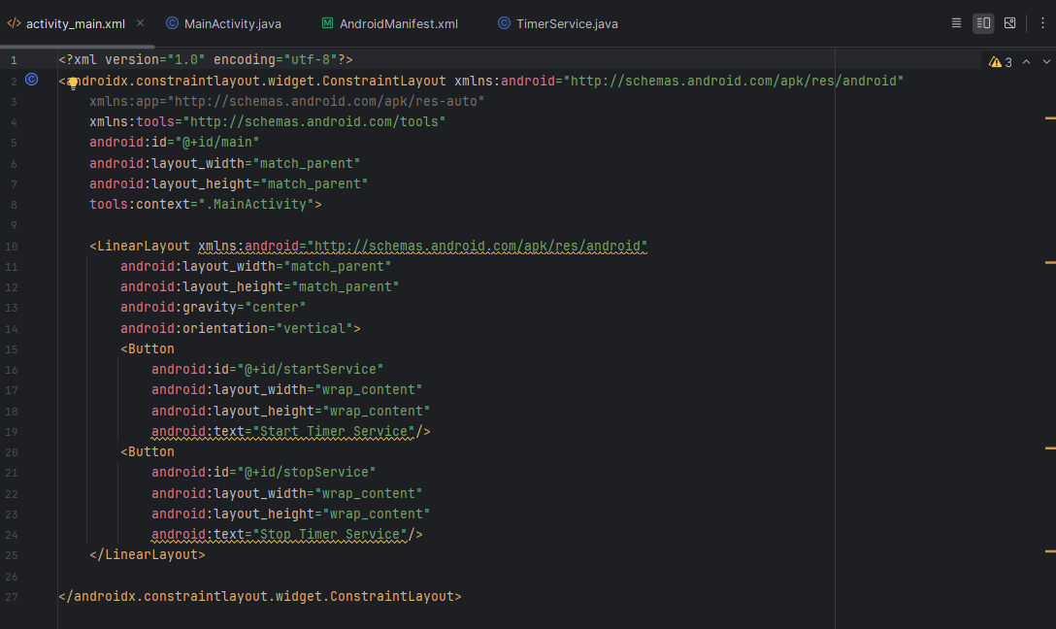

MainActivity.java
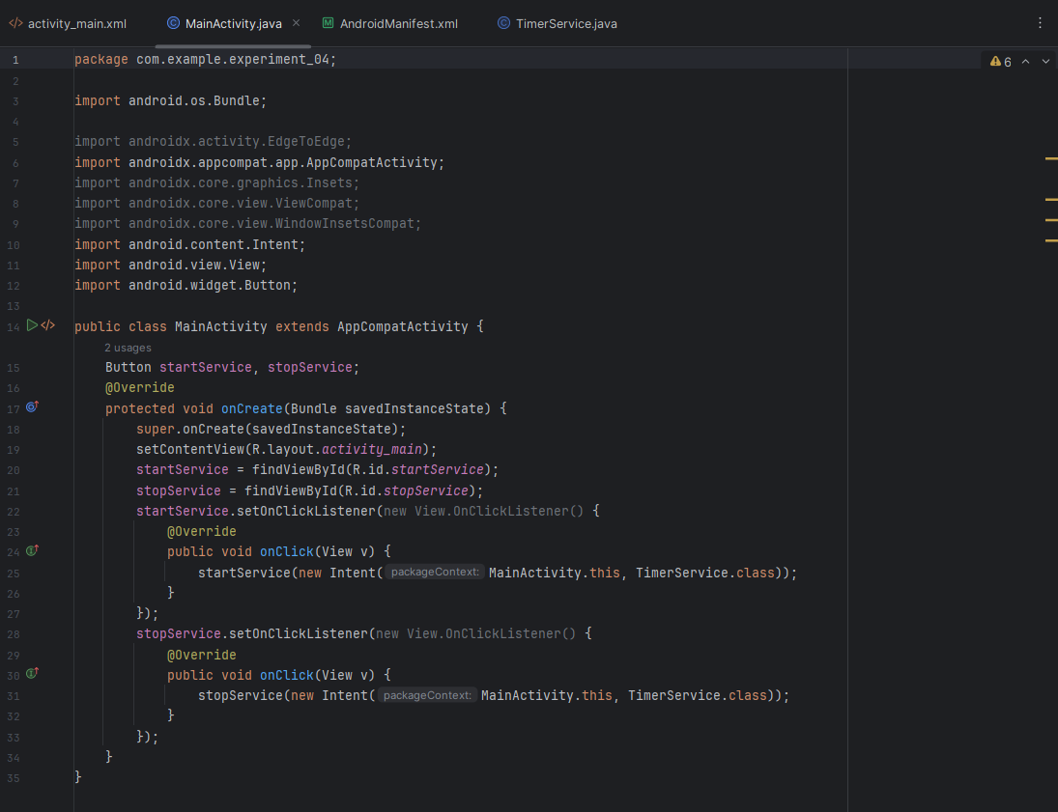

AndroidManifest.xml
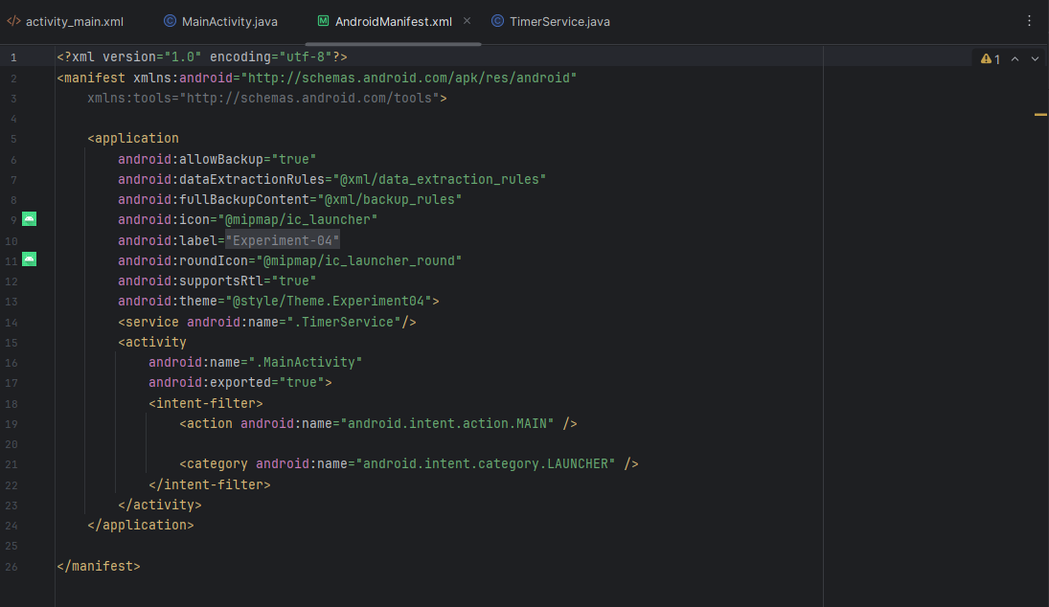

Output:
- Background Execution
  - Service runs independently of UI in the background
- Timer Functionality
  - Timer increases every second continuously
- Real-time Output
  - Displays Toast message: Timer: X seconds
- User Control
  - Start button starts the service
  - Stop button stops the service
- Service Lifecycle
  - onCreate() → Service initialized
  - onStartCommand() → Timer runs
  - onDestroy() → Service stops
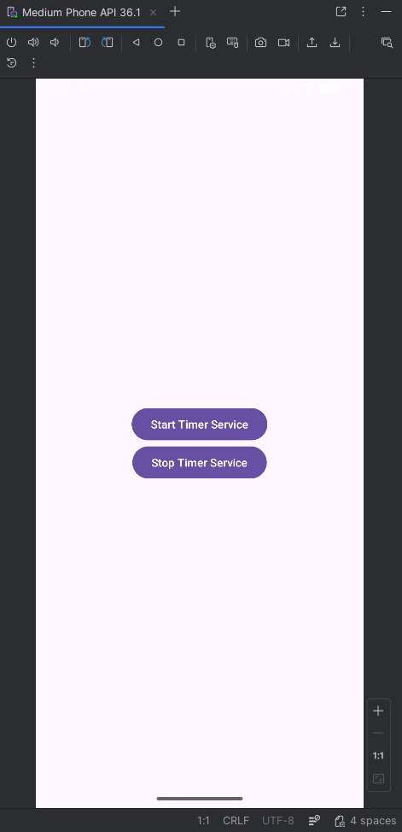 | 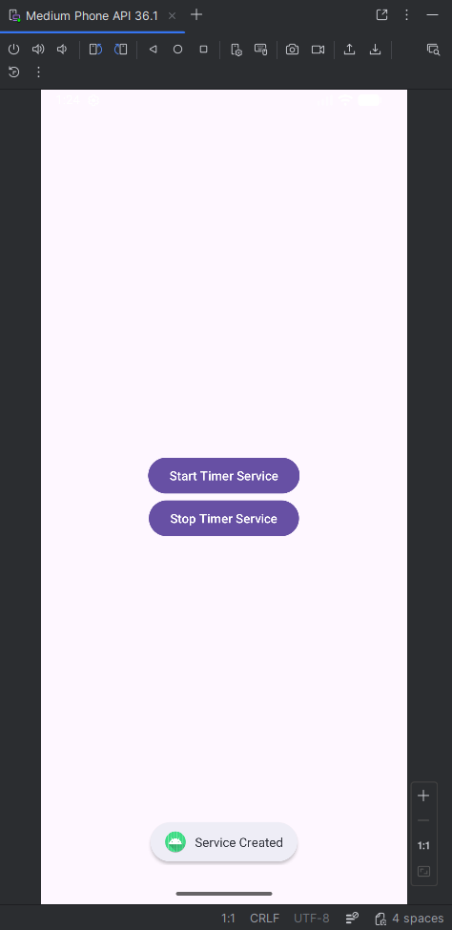 | 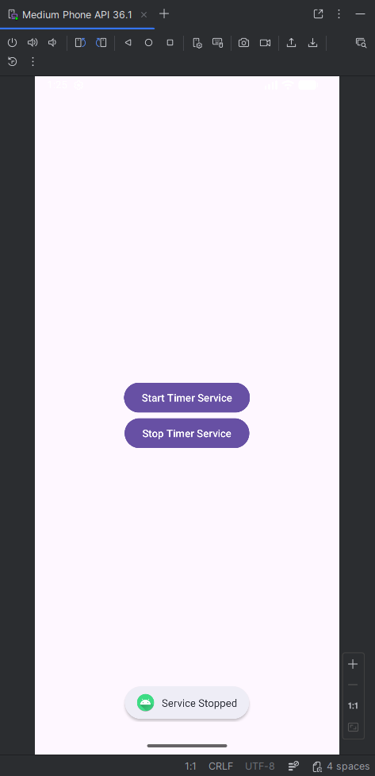

Conclusion
This practical demonstrates how Android Services perform background tasks and how they can be controlled using user interface components.

